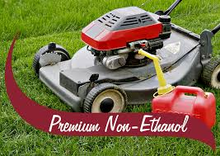
Ethanol fuel, a gas additive, is everywhere! Nowadays, the gas you pump from almost every gas station contains a blend of gasoline and ethanol. The percentage of ethanol blend is indicated by the E number. For example E10 means the gas mixture contains 90% gas and 10% ethanol. In automobiles, ethanol fuel won’t do much harm to your car's engine. However, when you're using gas with ethanol mixture in your outdoor power and lawn equipment, boats, and antique motors you run the risk of engine damage and incurring costly repairs. Not to mention, voiding out warranties on those expensive items.
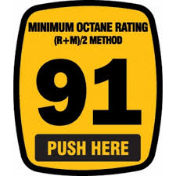
Why use Dickneite Oil Company (DOC) Sinclair Super Unleaded?
-91% Octane and Contains NO Ethanol
-Review your equipment warranties (most warranties state No Ethanol)
-Great also for your antique motors
What happens if you don't use Super Unleaded with No Ethanol?
-Your equipment repair is NOT covered by warranties
-If the gas sits in your equipment it eats away the gas seals
How can D.O.C. help?
-We sell your product at our Office location. Bring your gas tanks, boats or vehicles in for a fill
-We also offer home delivery

Call us if you have questions regarding with the Pros of using DOC Super Unleaded.

But Most Importantly . . . Drive with Care and Buy Sinclair!

